NUMERICAL MESOSCALE MODELLING OF MICROSTRUCTURES IN INCONEL 617

Project Report

Submitted in partial fulfillment of the requirements for the award of the degree of

Bachelor of Technology
in

Mechanical Engineering

By

SANDHRA M LAL (Roll No.: B201054ME) AISWARYA R (Roll No.: B201046ME) THANVIR DIOUF (Roll No.: B201120ME)
MAMIDI MAHIMA PRAHARSHA (Roll No.: B201140ME)



Department of Mechanical Engineering NATIONAL INSTITUTE OF TECHNOLOGY CALICUT
May 2024

CERTIFICATE
This is to certify that the report entitled “Numerical Mesoscale Modelling of Microstructures in Nickel-Based Superalloy” is a bonafide record of the Project done by Sandhra M Lal (B201054ME), Aiswarya R (B201046ME), Thanvir S Diouf (B201120ME), Mamidi Mahima Praharsha (B201140ME) under my supervision, in partial fulfillment of the requirements for the award of the degree of Bachelor of Technology in Mechanical from National Institute of Technology Calicut, and this work has not been submitted elsewhere for the award of a degree.

Dr. Jinu Paul
(Guide)
Assistant Professor
Dept. of Mechanical Engineering

Dr. Arun Babu
(Co-Guide)
Associate professor
Dept. of Mechanical Engineering

Dr.M.L.Joy Professor & Head
Dept. of Mechanical Engineering

Place : NIT Calicut
Date : 29 April 2022

ABSTRACT

In the past, very little effort was made to explore the formability behaviour of high-strength super alloys like Inconel 617 alloy. This project develops a systematic method for the investigation of warm-forming procedures for Inconel 617.

A 2-D standalone CA program was developed in Java to investigate the microstructural evolution during warm forming. The initial grain size, temperature, strain rate, and strain are entered into the 2-D CA model as input data. The simulation's output data include the flow curve, final dynamic recrystallization (DRX) grain diameter (DDRX), and DRX fraction (XDRX). The simulation is run at various strain rates and temperatures by altering the simulation parameters to match the simulation output with the experimental results.

The parameters for work hardening and flow softening were computed. Peak stress and temperature were shown to be related. A relationship between the flow softening parameter and the temperature was also discovered. The mobility parameter was optimized, and the anticipated and experimental findings were confirmed.

KEYWORDS: Inconel 617, cellular automata, work hardening, flow softening

ACKNOWLEDGEMENT

I would like to express my sincere gratitude to our project guides Dr. Jinu Paul and Dr. Arun Babu for their invaluable support throughout this endeavor. Their guidance has been instrumental in shaping the direction of our project, providing valuable insights, and offering constructive feedback that significantly contributed to its success. Their commitment to our learning and development has been evident in the time and effort they invested in mentoring us, sharing their expertise, and patiently addressing our queries.

I extend my heartfelt thanks for their unwavering encouragement and belief in our abilities. Their mentorship has not only enhanced our technical skills but also fostered a sense of confidence and resilience in facing challenges. Their dedication to ensuring our growth and understanding of the subject matter has left a lasting impact on each team member.

SANDHRA M LAL (Roll No.: B201054ME) AISWARYA R (Roll No.: B201046ME)
THANVIR DIOUF S (Roll No.: B201120ME)
MAMIDI MAHIMA PRAHARSHA (Roll No.: B201140ME)

CONTENTS
List of Abbreviations | ii
List of Symbols | iii
List of Figures | iv
List of Tables | v
Chapter 1 - Introduction | 1
1.1 Introduction | 1
1.2 Problem Definition | 2
1.3 Outline of the Report | 2
1.4 Model Description | 3
Chapter 2 - Review of Literature | 5
2.1 Major conclusions of each paper | 6
Chapter 3 -Methodology | 10
3.1 Cellular Automaton model | 10
3.2 Briefing on Work done | 12
3.2.1 For constant temperature and strain rate | 12
3.2.2 For constant strain and varying temperature | 13
Chapter 4 – Results | 16
Chapter 5 - Conclusions and scope for future work | 19
5.1 conclusion | 19
5.2 future scope | 19
References | 20

LIST OF ABBREVIATIONS

TMP - Thermomechanical processing WH - Work hardening
DRV - Dynamic recovery
DRX - Dynamic recrystallization CA - Cellular automata model
DRX - Dynamic Recrystallization Grain Diameter XDRX - Dynamic Recrystallization Fraction CAC - Conventional Cellular Automaton
CAM - Modified Cellular Automaton
LR - Linear regression
PINN - Physical Informal Neural Network
TMP – Thermomechanical processing
ANN - Artificial Neural Network

LIST OF SYMBOLS

g: Grain size t: Time
R: gas constant
T: absolute temperature ρ: Dislocation density µ: Mobility
K1: Work hardening parameter K2: Flow softening parameter
$σ_{p}$: Peak stress
G: Shear Modulus
Z: Zenner Hollomon Parameter
$\dot{ε}$ : Strain rate
$Q_{p}$ : Activation Energy
R: Gas Constant = 8.314 J⋅mol⁻¹⋅K⁻¹
T: Temperature
$Q_{n}$ : activation energy for nucleation.
$Q_{f}$ : Activation energy for diffusion
$σ_{p}$: Peak Stress
G: Shear Modulus
α: Constant and the values of K₁ and K₂ can be evaluated from Kocks- mecking plot

LIST OF FIGURES

- Fig. 1: Cellular Automata
- Fig. 2: Flow chart of CA simulation
- Fig. 3: Diagram of a Neuron in ANN
- Fig. 4: (a) Schematic illustration of Kocks-Mecking plot, (b) variation of lnK2 vs lnZ
- Fig. 5: Obtained Kocks-Mecking Plot
- Fig. 6: obtained variation of lnK₂ vs. ln Z
- Fig. 7: Curve Fitting of Sp vs T
- Fig. 8: Curve Fitting of k2 vs T
- Fig. 9: Pictural output of microstructures
- Fig. 10: Stress vs Strain Graph: Experimental and Calculated

LIST OF TABLES

- Table 2.1: Literature Review
- Table 4.1 Experimental Data
- Table 4.2. Calculated values

CHAPTER 1 INTRODUCTION

INTRODUCTION

Superalloys unlike other alloys and metals show distinctive properties. They are high-performance materials known for their exceptional mechanical strength, resistance to high temperatures, corrosion, and oxidation resistance. They also show properties like Thermal creep resistance and Surface stability. These retain all these mechanical properties due to their unique combination of alloying components.

Inconel 617, a nickel-based Superalloy Intrigued us to study it. The remarkable mechanical qualities of this alloy are due to its carefully balanced combination of alloying elements, namely Ni-52.5%, Cr-19%, Fe-17%, and Mo-3.5%. It exhibits remarkable properties like High-temperature resistance and good oxidation and corrosion resistance, which makes it to be used to make catalyst grid support in Chemical industries, and combustion chambers which need high resilience to temperature in gas industries.

Inconel 617 boasts of remarkable properties that make it suitable for a wide range of applications in different industries such as Nuclear, Marine, and Oil. These industries leverage its exceptional features for various purposes.

Desired components for various applications are manufactured by Thermomechanical processing (TMP). Despite its formidable qualities, machining Inconel 617 can pose challenges due to its tendency to work harden quickly, generate excessive heat, and resist metal removal. However, traditional production processes can still be employed with careful consideration of machining parameters.

To create intricate shapes and structures with Inconel 617, thermomechanical processing (TMP) is often utilized. TMP involves manipulating the material's microstructure through controlled temperature and strain interactions. This process is vital for enhancing mechanical properties, but it requires a deep understanding of deformation mechanisms to avoid flow instabilities such as cracks and localization.
The cellular automata (CA) model has emerged as a valuable tool for predicting the behavior of materials like Inconel 617 during thermomechanical processing, particularly in dynamic recrystallization (DRX) scenarios. By carefully adjusting processing parameters such as temperature and strain rates, the workability of Inconel 617 can be optimized, either through dynamic recovery (DRV) or DRX.

In applications ranging from gas turbines to Nuclear industries, the performance of Inconel 617 hinges on its microstructure, which can be finely tuned through TMP. However, achieving optimal results requires a thorough understanding of the interplay between microstructure, flow behavior, and processing parameters. Therefore, efforts should focus on correlating these factors to enhance the overall performance and reliability of alloy 617 in various demanding environments.

PROBLEM DEFINITION

According to a thorough literature review, there is a lot of research on classic metallic alloys including steel, titanium, and aluminum under various testing situations. The past, however, saw very little work put towards understanding the formability behavior of high-strength super alloys like Inconel 617 alloy. This project delves into predicting the warm-forming behavior of Inconel alloy using the conventional 2-D cellular automata model. The predicted result is finally compared with the experimental one.

OUTLINE OF THE REPORT

The project aims to use a cellular automata model to predict the warm-forming behavior of the Inconel 617 alloy. The work hardening and flow softening parameters were calculated. A relation between peak stress and temperature was developed. An equation relating the flow softening parameter and temperature was also obtained. The mobility parameter was optimized and the predicted results were confirmed with the experimental result.

MODEL DESCRIPTION

1.4.1 Cellular Automaton
A cellular automaton (CA) is a group of cells structured in a grid of a particular shape, with each cell changing state as a function of time, according to a predetermined set of rules dictated by states of neighboring cells. A CA is discrete in both space and time, which implies that the cells that make up the CA represent one of a finite set of states in each time unit.

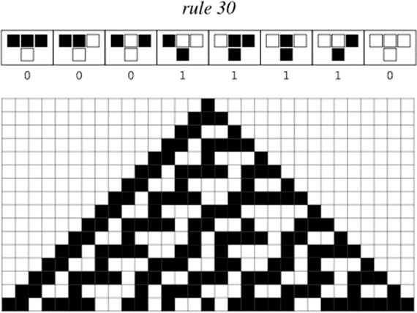
Furthermore, the cells in a grid evolve in parallel at discrete time steps by taking into account the statuses of neighboring cells. As a result, the CA evolves in discrete time steps according to a set of rules dependent on the states of neighboring cells. These rules can be implemented iteratively for as many time steps as needed.

Fig. 1.1: Cellular Automata (https://mathworld.wolfram.com/CellularAutomaton.html)

The following are typical CA characteristics:
- A CA's cells are organized on a grid with a specific shape (square, triangle, hexagon, etc.) and exist in a limited number of dimensions.
- Every grid cell has a state. While the state has many finite options, the most basic state form is commonly ON or OFF (or TRUE/FALSE or 1/0).
- The cells next to one another form a cell's neighborhood. Cells in a neighborhood influence one another, and every cell on the CA grid has a neighborhood.

Concerning the microstructure of nickel superalloy, new DRX grains nucleate at grain boundaries, and nucleation and growth events follow the probabilistic CA rules. The growth of each DRX grain is evaluated using a probabilistic approach paired with Moore neighborhoods, which ensures that DRX grains grow circularly.

The flowchart of the CA simulation is as follows:

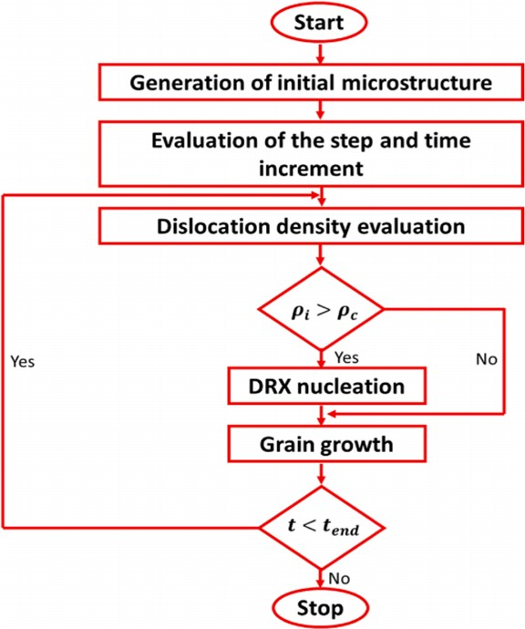

Fig 1.2: Flow chart of CA simulation

1.4.2 Linear regression
It was seen that the regression model approach was deficient in predicting desired parameters. Therefore, the ANN approach was used, and seen that more accurate results were obtained than LR.
Regression analysis is a method for determining the connection between dependent variables (response) and independent variables (predictor). In linear regression, the function is a linear equation, and the dependent variable can be written as a function of the independent variable(s) in the form of:
Normalizing equation,
$X_{norm}= \frac{X-mean(X)}{std(X)}$………………………………………………………………………….(1)
X represents the input data
Mean(X) is the Mean of input data
Std(X) is the Standard Deviation of input data
Mean Squared error,
$MSE= \frac{1}{n}\sum_{i=1}^{n}{{\left(y_{i}-{\hat{y}}_{i}\right)}^{2}}$……………………………………………………………………(2)
N is the number of Data points
$y_{i}$, is the Actual output
${\hat{y}}_{i}$, is the predicted output

1.4.3 Artificial Neural Networks
The human brain is an intricately structured, non-linear, and parallel computing system. The motivation for ANN comes from the fundamental structure of the human brain. An artificial neural network (ANN) consists of several interconnected processing components, similar to neurons in the brain.
A model is a black box that contains a set of equations used to calculate the output based on provided input values. A neuron k can be theoretically described using the following equations:
$u_{k}=\sum_{j=1}^{m}{W_{kj}x_{j}}$…………………………………………………………………………….(3)
$y_{k}=φ(u_{k}+b_{k})$……………………………………………………………………………(4)
Bias, represented as $b_{k}$, alters the net input of the activation function by either increasing or decreasing it.
$x_{1}$, $x_{2}$, ..., $x_{m}$ represent the inputs.
$W_{k1}$, $W_{k2}$, ..., $W_{km}$ represent the weights of neuron k.
$u_{k}$ represents the output of the linear combiner owing to the input signals.
$φ(.)$ represents the activation function.
$y_{k}$ represents the output signal of the neuron.
The backpropagation method is frequently employed as the learning algorithm for artificial neural networks in multilayered feedforward networks. In backpropagation networks, data undergoes processing as it flows sequentially from the input layer to the hidden layer and finally to the output layer. The objective is to determine the ideal weights that will yield output values close to the desired targets.
Diagram of a neuron:

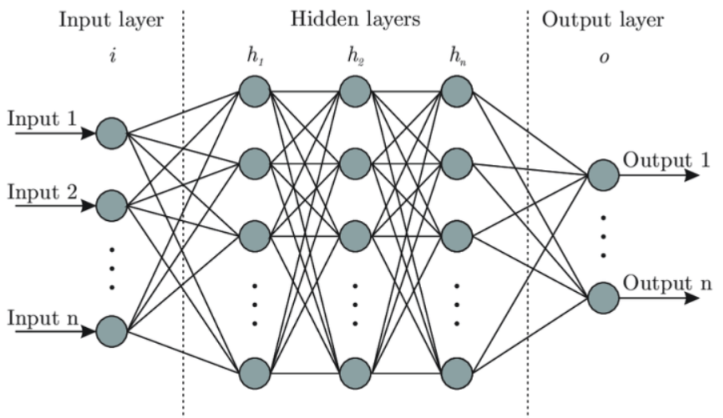
Fig 1.3: Diagram of a Neuron in ANN

1.4.4 Physical Informal Neural Network (PINN)
To produce neural networks that are informed by physics, we take advantage of recent advancements in automated differentiation, one of the most helpful but possibly underutilized approaches in scientific computing, to differentiate neural networks about their input coordinates and model parameters. Such neural networks are conditioned to adhere to any conservation rules, symmetries, or invariances derived from the physical laws governing the observed data, which are represented by general time-dependent, nonlinear partial differential equations. This straightforward but effective construction allows us to address a broad range of computational science problems. It introduces a potentially revolutionary technology that will enable the creation of new classes of numerical solvers for partial differential equations, data-driven approaches for model inversion, and data-efficient and physics-informed learning machines.

TABLE 2
CHAPTER 2

REVIEW OF LITERATURE

SL.NO | AUTHORS | CRITERION ADOPTED | INFERENCES
1. | K. Arun Babu, et al (2021) | Modeling and simulation of dynamic recrystallization in super austenitic  stainless steel employing combined cellular automaton, artificial neural  network and finite element method. | The Development of a Cellular Automaton (CA) model aimed at refining the prediction of dynamic recrystallization (DRX) in super austenitic stainless steel.  The focus is on incorporating solute drag effects to enhance the accuracy of DRX and flow behavior predictions.
2. | Yan-Xing Liu, et al (2017) | 2D cellular automaton simulation of hot deformation behavior in a Ni-based  superalloy under varying thermal-mechanical conditions | A 2D cellular automaton model accurately forecasts the hot deformation behavior of a Ni-based superalloy.  This model reveals an innovative occurrence termed "pseudo-metadynamic recrystallization," observed particularly during rapid changes in strain rates.
3. | K. Arun Babu, et al  (2016) | Characterization of hot deformation behavior of alloy 617 through  kinetic analysis, dynamic material modeling and microstructural  studies | The Study of the hot deformation characteristics of alloy 617, particularly observing the occurrence of unexpected dynamic recrystallization at elevated temperatures and under varying strain rates.
4. | Yan-Xing Liu, et al | Study of Grain Growth in a Ni- Based Superalloy by | The research demonstrates that in a Ni-based superalloy, the grain growth during

 | (2021) | Experiments and Cellular Automaton Model | isothermal heat treatment is impacted by temperature.  The implemented Cellular Automaton (CA) model adeptly characterizes both the kinetics of grain growth and its dependency on size.
5. | R. Ding, Z.X. Guo (2002) | Microstructural modelling of dynamic recrystallisation using  an extended cellular automaton approach | A cellular automaton model is used to simulate the process of dynamic recrystallization in a titanium alloy.  This model establishes a connection between mesoscopic dislocation behavior and the resulting macroscopic mechanical properties.

MAJOR CONCLUSIONS OF EACH PAPER

- Modeling and simulation of dynamic recrystallization in super austenitic stainless steel employing combined cellular automaton, artificial neural network and finite element method., K. Arun Babu, et al (2021):
- Developed CA (Cellular Automaton) models that simulated flow behavior and microstructure evolution of super austenitic stainless steel under various strain rates and temperatures.
- ANN-based constitutive models accurately estimated flow stress but required numerical procedures for DDRX (Dynamic Recrystallization Grain Diameter) and XDRX (Dynamic Recrystallization Fraction) during FEM simulations.
- The CAC (Conventional Cellular Automaton) model’s representation of microstructure evolution was inadequate due to its failure to consider solute drag effects.
- CAM (Modified Cellular Automaton) model, addressing this limitation, displayed improved predictive capabilities, accurately predicting microstructural changes and flow behavior with higher correlation coefficients during non-isothermal simulations.
- CAM model highlighted significant adiabatic heating effects on XDRX at specific temperature-strain rate conditions.

- 2D cellular automaton simulation of hot deformation behavior in a Ni-based superalloy under varying thermal-mechanical conditions., Yan-Xing Liu, et al (2017):

- A 2D cellular automaton (CA) model has been developed effectively to characterize the hot deformation properties of a Ni-based superalloy.
- This was achieved by establishing relationships between model parameters (such as work hardening parameter, dynamic recovery parameter, nucleation rate, and grain boundary mobility) and thermal-mechanical variables.
- The CA model demonstrates a high degree of correspondence between its predicted results and experimental findings, thereby confirming its effectiveness in accurately representing the alloy's behavior during hot deformation processes.
- The CA model approximates outcomes attained under consistent hot deformed conditions when exposed to different thermal-mechanical conditions, which is referred to as pseudo-metadynamic recrystallization. This phenomenon, known as pseudo-metadynamic recrystallization, refers to a transition in the process of dynamic recrystallization when there is a sudden increase in strain rate.
- This pause is caused by the inhibition of nucleation and requires additional experimental validation. Unlike traditional finite element simulation methods, the newly developed CA method accurately represents the complex behaviors of hot deformation and the resulting changes in microstructure under various thermal-mechanical conditions.

- Characterization of hot deformation behavior of alloy 617 through kinetic analysis, dynamic material modelling, and microstructural studies., K. Arun Babu, et al (2016):
- Mathematical relationships were established between the Zener–Hollomon parameter (Z) and peak stress, as well as between peak strain (εp) and Z.
- The average activation energy for the entire hot deformation range of alloy 617 was calculated at 481 Kj mol^-1.
- Dynamic material models were utilized to construct processing maps for alloy 617 at varying strain levels.
- Strain exhibited minimal impact on the efficiency map, yet higher strain values notably reduced instability at elevated strain rates.88 Alloy 617 displayed a broad stable domain at lower strain rates and temperatures, spanning from 1250–1473 K, achieving a peak efficiency of approximately 45%.
- The identified optimal hot deformation range for alloy 617 was determined as 1323–1423 K and 0.001–0.1 s^-1 based on processing maps and microstructural observations88 Within specific strain rate and temperature ranges, an unstable domain revealed heavily deformed grains without a significant fraction of dynamic recrystallization (DRX).
- A distinctive rise in DRX fraction marked the transition from unstable to stable processing domains.

- Study of Grain Growth in a Ni-Based Superalloy by Experiments and Cellular Automaton Model., Yan-Xing Liu, et al (2021):
- The study explores grain growth behavior in a Ni-based superalloy through isothermal heat treatment experiments.
- Results indicate continuous grain structure coarsening with increased holding time and temperature.
- A classical grain growth model reveals a predominantly grain boundary migration mechanism, with minor pinning effects from precipitates.
- A cellular automaton model is employed to simulate grain growth kinetics, correlating grain boundary velocity with curvature.
- Grain boundary mobility is found to increase with temperature.
- Overall, the study provides insights into grain growth mechanisms and offers a model capable of predicting grain size changes under different heat treatment conditions.

- Microstructural modelling of dynamic recrystallisation using an extended cellular automaton approach., R. Ding, Z.X. Guo (2002):
- The combination of a Cellular Automaton (CA) model with metallurgical principles provides an excellent simulation of microstructural changes that occur during Dynamic Recrystallization (DRX) in single-phase metallic materials.
- This model analyzes the impact of processing settings on dynamic recrystallization (DRX) levels and is consistent with experimental findings, especially in a Ti–6Al–4V alloy.
- It is evident that when the rate of DRX nucleation is minimally affected by the strain rate, consistent microstructures are observed at different combinations of strain rates and temperatures for a specific Zener-Hollomon parameter.
- However, when the strain rate significantly impacts nucleation, the resulting microstructures vary.

CHAPTER 3 METHODOLOGY

Cellular automaton modelling

In material science, work hardening (strain hardening) is the strengthening of metal or polymer by plastic deformation. Work hardening may be desirable, undesirable, or inconsequential depending on the context. Flow stress, during work hardening, increases with the generation and multiplications of dislocations. During dynamic recovery, dislocation gets annihilated, and this variation of dislocation density (𝜌) could be expressed by the Kocks-Mecking (KM) relation as follows,
$\frac{dρ}{ds}- K_{1}.\sqrt{\overline{ρ}}= \frac{1}{bd}- K_{2}ρ$
Throughout the simulation, the dislocation density gets updated based on the KM relation, and the resultant flow stress is evaluated based on the following
$σ=αμb \sqrt{\overline{ρ}}$……6)
The nucleation of new grains occurs when the dislocation density exceeds the value of critical dislocation density. The change in the value of dislocation density after nucleation is not linear, it first drops to zero and then rises to a steady state dislocation density during hardening. The dislocation density from the steady state deformation is used to model the kinetics of dynamic recrystallization during deformation. The dislocation of the deformed matrix then reaches the saturation densities. All of these dislocation densities are evaluated using the flow curves.
In the simulation, the nucleated grains grow to achieve a spherical shape. The energy change associated with this is evaluated based on the following mathematical expressions
$dW_{i}=dW_{i}^{S}+ dW_{i}^{V}$………………………………………………………………………(7)
$dW_{i}^{S}=-d\left(4πr_{i}^{2}γ_{i}\right)=-8πr_{i}γ_{i}dr_{i}$……………………………………………………….(8)
$dW_{i}^{V}=4πr_{i}^{2}r\left(ρ_{m}-ρ_{i}\right)dr_{i}$……………………………………………………………….(9)

The driving force for boundary migration of the boundary pressure of the i^{th} grain was evaluated using the following relation,
$F_{i}=\frac{dW_{i}}{dr_{i}}=4πr^{2}r_{i}\left(ρ_{m}-ρ_{i}\right)-8πr_{i}$………………………………………………………(10)

The value of 𝛾_{𝑖} was evaluated using the Read-Shockley relationship,
$γ_{i}=γ_{m}\frac{θ_{i}}{θ_{m}}\left(1-ln\left(\frac{θ_{i}}{θ_{m}}\right)\right)$………………………………………………………………………(11)

In the model, we are assuming that the grain boundary moves with a velocity, this velocity is given by
𝑉 = $µ$ 𝑃……….(12)

The variation of mobility ($µ$) with temperature is evaluated using the following
$µ=\frac{ D_{b}×b }{K_{2}T}$…………………..(13)

Where $D_{b}$ is Boundary self-diffusion coefficient:
$D_{b}=1.7×{10}^{-22}×e^{\left(-\frac{Q_{f}×1000}{RT}\right)}×e^{Q_{f}×0.091}$…………………………………………(14)
$Q_{f}$ = Activation energy for diffusion
Modeling of work hardening and softening parameters
The flow stress behavior during Warm-forming could be modeled using the KM relation. The accurate values of 𝑘1 and 𝑘2 are necessary to model the work-hardening behaviors. This was evaluated using the equation
$K_{1}= \frac{K_{2}σ_{p}×{10}^{6}}{αGb}$………………………………………………………………………….(15)

Here, b = burger vector = 2.5x10⁻¹⁰
Burgers’ vector characterizes the magnitude and direction of lattice distortion associated with a dislocation.
$σ_{p}$ = Peak Stress
G = Shear Modulus
α is a constant and the values of $K_{1}$ and $K_{2}$ can be evaluated from Kocks- mecking plot.
The peak stress can be evaluated from the equation,
$σ_{p}= \frac{1}{0.005439} ln⁡\left(\sqrt{{\left(e^{\frac{\ln\left(Z\right)-40.26}{3.86}}\right)}^{2}}+1+ e^{\frac{\ln\left(Z\right)-40.26}{3.86}}\right)$…………………………..…….(16)

$G=78.9×{10}^{9}×\left(1-0.64×\frac{T-300}{T_{m}+273}\right)$……………………………………(17)
The Zenner Hollomon Parameter Can be evaluated from the equation,
$Z= \dot{ε}e^{\frac{Q_{p}}{RT}}$ ……………………………………………………………………………………………………………………………(18)
Z = Zenner Hollomon Parameter
$\dot{ε}$ = Strain rate
$Q_{p}$ = Activation Energy
R = Gas Constant = 8.314 J⋅mol⁻¹⋅K⁻¹
T = Temperature

The variation of 𝑙𝑛𝑘₂ was plotted against 𝑙𝑛𝑍 which yields the following-

$ln⁡(K_{2})= 8.9-0.15(ln⁡(Z))$……………………………………………………………(19)

The value of 𝑘1 was evaluated using the following relation
$σ_{sat}=0.5μ\frac{K_{1}}{K_{2}}$……………………………………………………………………………(20)

Nucleation Rate,
The nucleation rate is a convenient synthesis of terms that describes how many nuclei of critical size form on a substrate per unit area, per unit time.
It is obtained from the equation,
$\dot{N}=3.83×{10}^{15}×e^{\left(-\frac{Q_{n}×1000}{RT}\right)}×{\left(\frac{\dot{ε}}{0.2}\right)}^{n_{p}}$………………………………………….……(21)
$Q_{n}$ = activation energy for nucleation.

Dislocation Energy,
$E_{b}= αGb^{2}$………………………………………………………………………………(22)
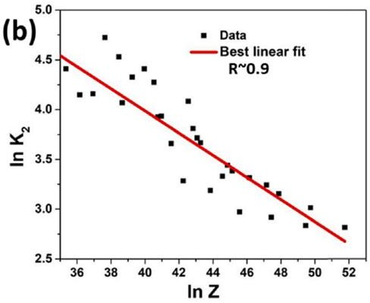
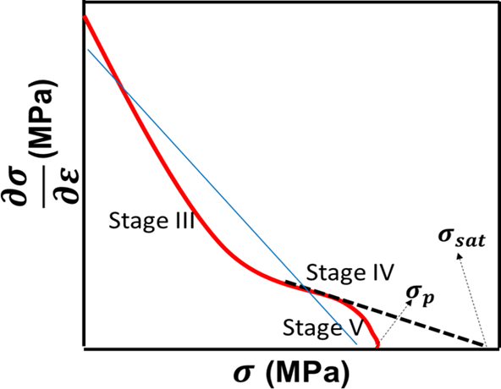

Fig 3.1. (a) Schematic illustration of Kocks-Mecking plot, (b) variation of lnK2 vs lnZ

CHAPTER 4

WORK DONE

4.1 Briefing on Last Semester Work done
A 2-D standalone CA program was created and modified using Java to investigate the evolution of microstructural evolution during warm forming. The initial grain size, temperature, strain rate, and strain are set as the input data.
4.1.1 For constant temperature and strain rate
The values of k1 and k2 at a fixed temperature and strain rate are calculated employing the Zenner- Holmon parameter. The Java simulation uses these values to represent the behaviors of the superalloy during deformation. Algorithms and rules within the cellular automata are developed to mimic the material's response to plastic deformation. The CA model divides the material into discrete cells, each representing a portion of the material microstructure, and updates their states based on a set of predefined rules. Upon executing the CA model, the evolution of the grain structure is observed over time, capturing the dynamic changes in the material's microstructure. The significant patterns observed in the final grain structures are summarized

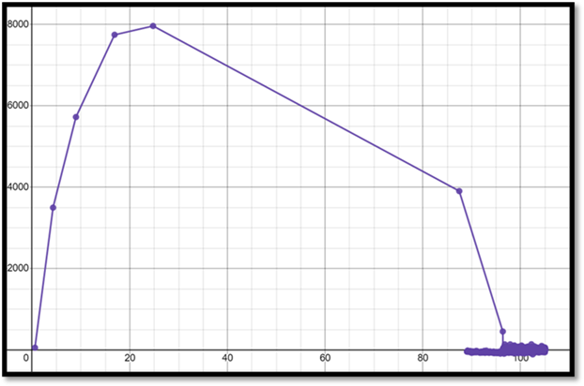
Fig 4.1. Obtained Kocks-Mecking
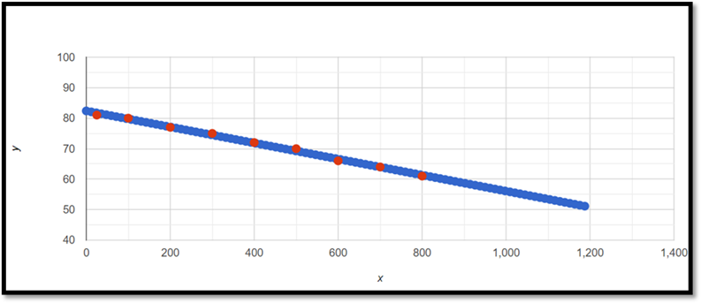
Fig 4.2: obtained variation of lnK₂ vs. ln Z

    - For constant strain and varying temperature
Work hardening and flow softening parameters are then obtained at a fixed strain rate and a specified temperature range. To establish a precise mathematical relationship between the flow softening parameter (k2) and temperature(T) variations, curve fitting methods are applied.
Curve fitting involves finding the best-fitting curve that represents the experimental data points. This mathematical approach helps create a functional form that describes how the flow softening parameter changes with temperature. Common techniques include least squares fitting, which minimizes the difference between the predicted and observed values, enabling the derivation of an equation expressing the relationship between k2 and temperature.
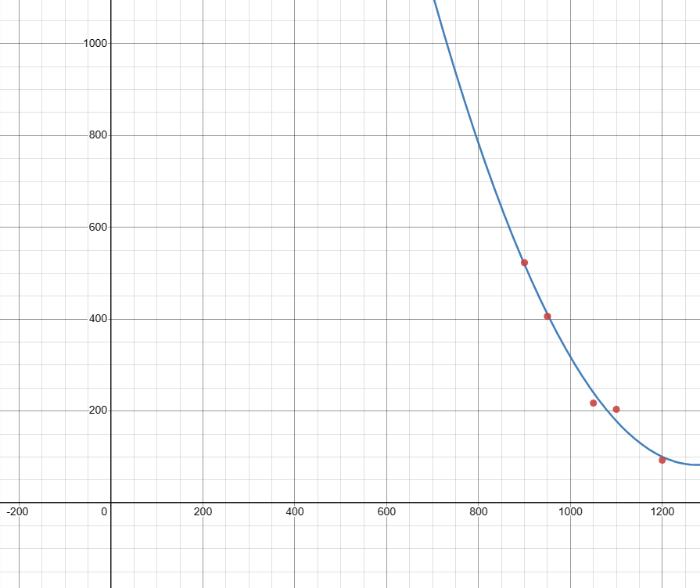
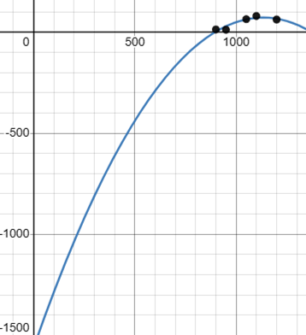

Fig 4.3: Curve Fitting of $σ_{p}$ vs T and Curve Fitting of k2 vs T
Similarly, curve fitting is done between peak stress ($σ_{p}$) and temperature (T) to derive an equation that accurately describes how peak stress varies with temperature. This provides valuable insight into the material's strength at different temperature conditions.
In the simulation program, an important aspect is aligning the output with existing empirical data. To achieve this alignment, the mobility parameter is adjusted. The mobility parameter affects the movement of dislocations within the material, influencing its plastic deformation behavior.
All these steps collectively contribute to a comprehensive understanding of materials behavior under varying temperature conditions.


The final output from this code is

Fig 4.4: Pictural output of microstructures

Graphical representation of the Excel output:
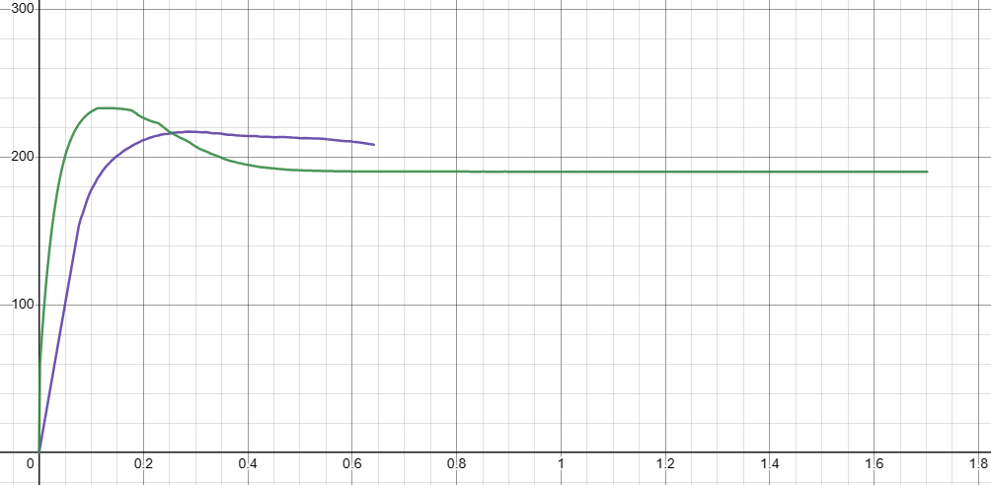
Stress vs Strain graph
— = Real Data
— = Calculated value

Fig 4.5: Stress vs Strain
Graph: Experimental and Calculated

4.2 Briefing on Work done till Mid Semester

4.2.1 Incorporating temperature dependency in mobility and nucleation rate
Instead of using constant values, mobility, and nucleation rate is now determined by an equation that encapsulates its reliance on temperature. This dependency is expressed as a function of the following parameters, boundary thickness (δ), boundary self-diffusion coefficient (D_{ob}), and activation energy (Q_{b}).

4.2.2 Experimentation for enhancing the accuracy
Few trials were conducted to obtain the optimal value for the product δ.Dob.
This enabled us to fine-tune the simulation model, ensuring it reflects real-world behavior more accurately.

4.2.3 Temperature effects on peak stress and flow softening parameters
The Peak stress ($σ_{p}$) and flow softening parameter (K2) variations with temperature were graphed.
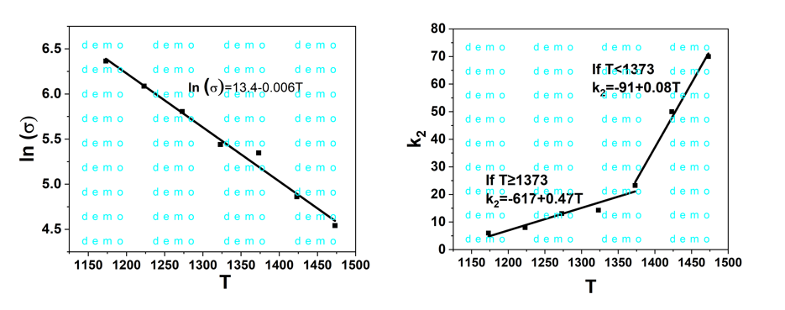Fig 4.6: A plot between peak stress vs temperature and flow softening parameter vs Temperature

4.2.4 Relationship between the grain diameter and the side length of the cell
The relation between the grain diameter (DDRX, in µm), length of the cell (LCA, in µm) was observed at a temperature of 1323 K and strain rate 0.2s-1
The polynomial fitting was done using Origin software.

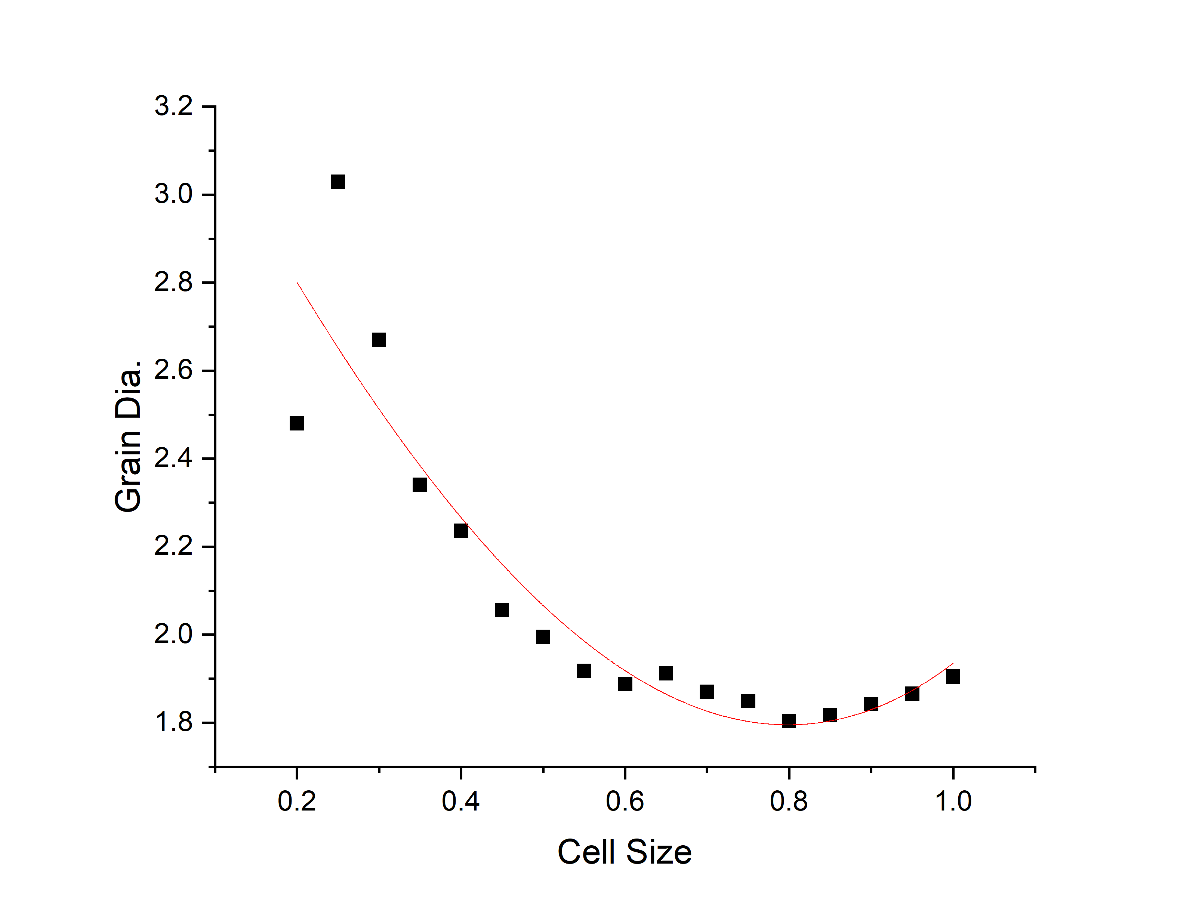
Fig 4.7: A plot between cell size vs Grain diameter
4.2.5 Development of a linear regression model
A model was developed to enhance the accuracy of the CA model. It incorporates the temperature, average grain diameter (DDRX), and recrystallization fraction (XDRX).
Training of the model involved utilizing the data obtained from both the CA model and experimental results for dependent variables, and Predicted results at intermediate temperatures were presented in a DataFrame and graphically visualized.
The mean square error and the coefficient of regression were computed to assess the model's performance.

Final output:

CHAPTER 5

RESULTS

Results

CHAPTER 5
CONCLUSIONS AND SCOPE FOR FUTURE WORK

CONCLUSION

The following conclusions were made in the present study:
- A conventional 2-D cellular automata model to predict the microstructural behavior of Inconel 617 alloy under warm worming conditions was implemented in Java and its parameters like a hardening parameter, softening parameter, and mobility were modified to best match the experimental results.
- A relationship between peak stress vs. temperature and flow softening parameter vs. Temperature were established.

FUTURE SCOPE

REFERENCE

[1].K. Arun Babu, T.S. Prithiv, A. Gupta, S. Mandal, Modeling and simulation of dynamic recrystallization in super austenitic stainless steel employing combined cellular automaton, (2021) .

[2]Ding, Ruoxi & Guo, Z. Xiao. Microstructural modelling of dynamic recrystallisation using an extended cellular automaton approach. Computational Materials Science.(2002)

[3].Yan-Xing Liua, Y.C. Lina, Ying Zhoua, 2D cellular automaton simulation of hot deformation behavior in a Ni-based superalloy under varying thermal-mechanical conditions.(2017)

[4].Yan-Xing Liu, et.al, Study of Grain Growth in a Ni-Based Superalloy by Experiments and Cellular Automaton Model.(2021)

[5] Babu, K. A., Mandal, S., Kumar, A., Athreya, C., De Boer, B., & Sarma, V. S. Characterization of hot deformation behavior of alloy 617 through kinetic analysis, dynamic material modeling and microstructural studies. Materials Science and Engineering (2016).

